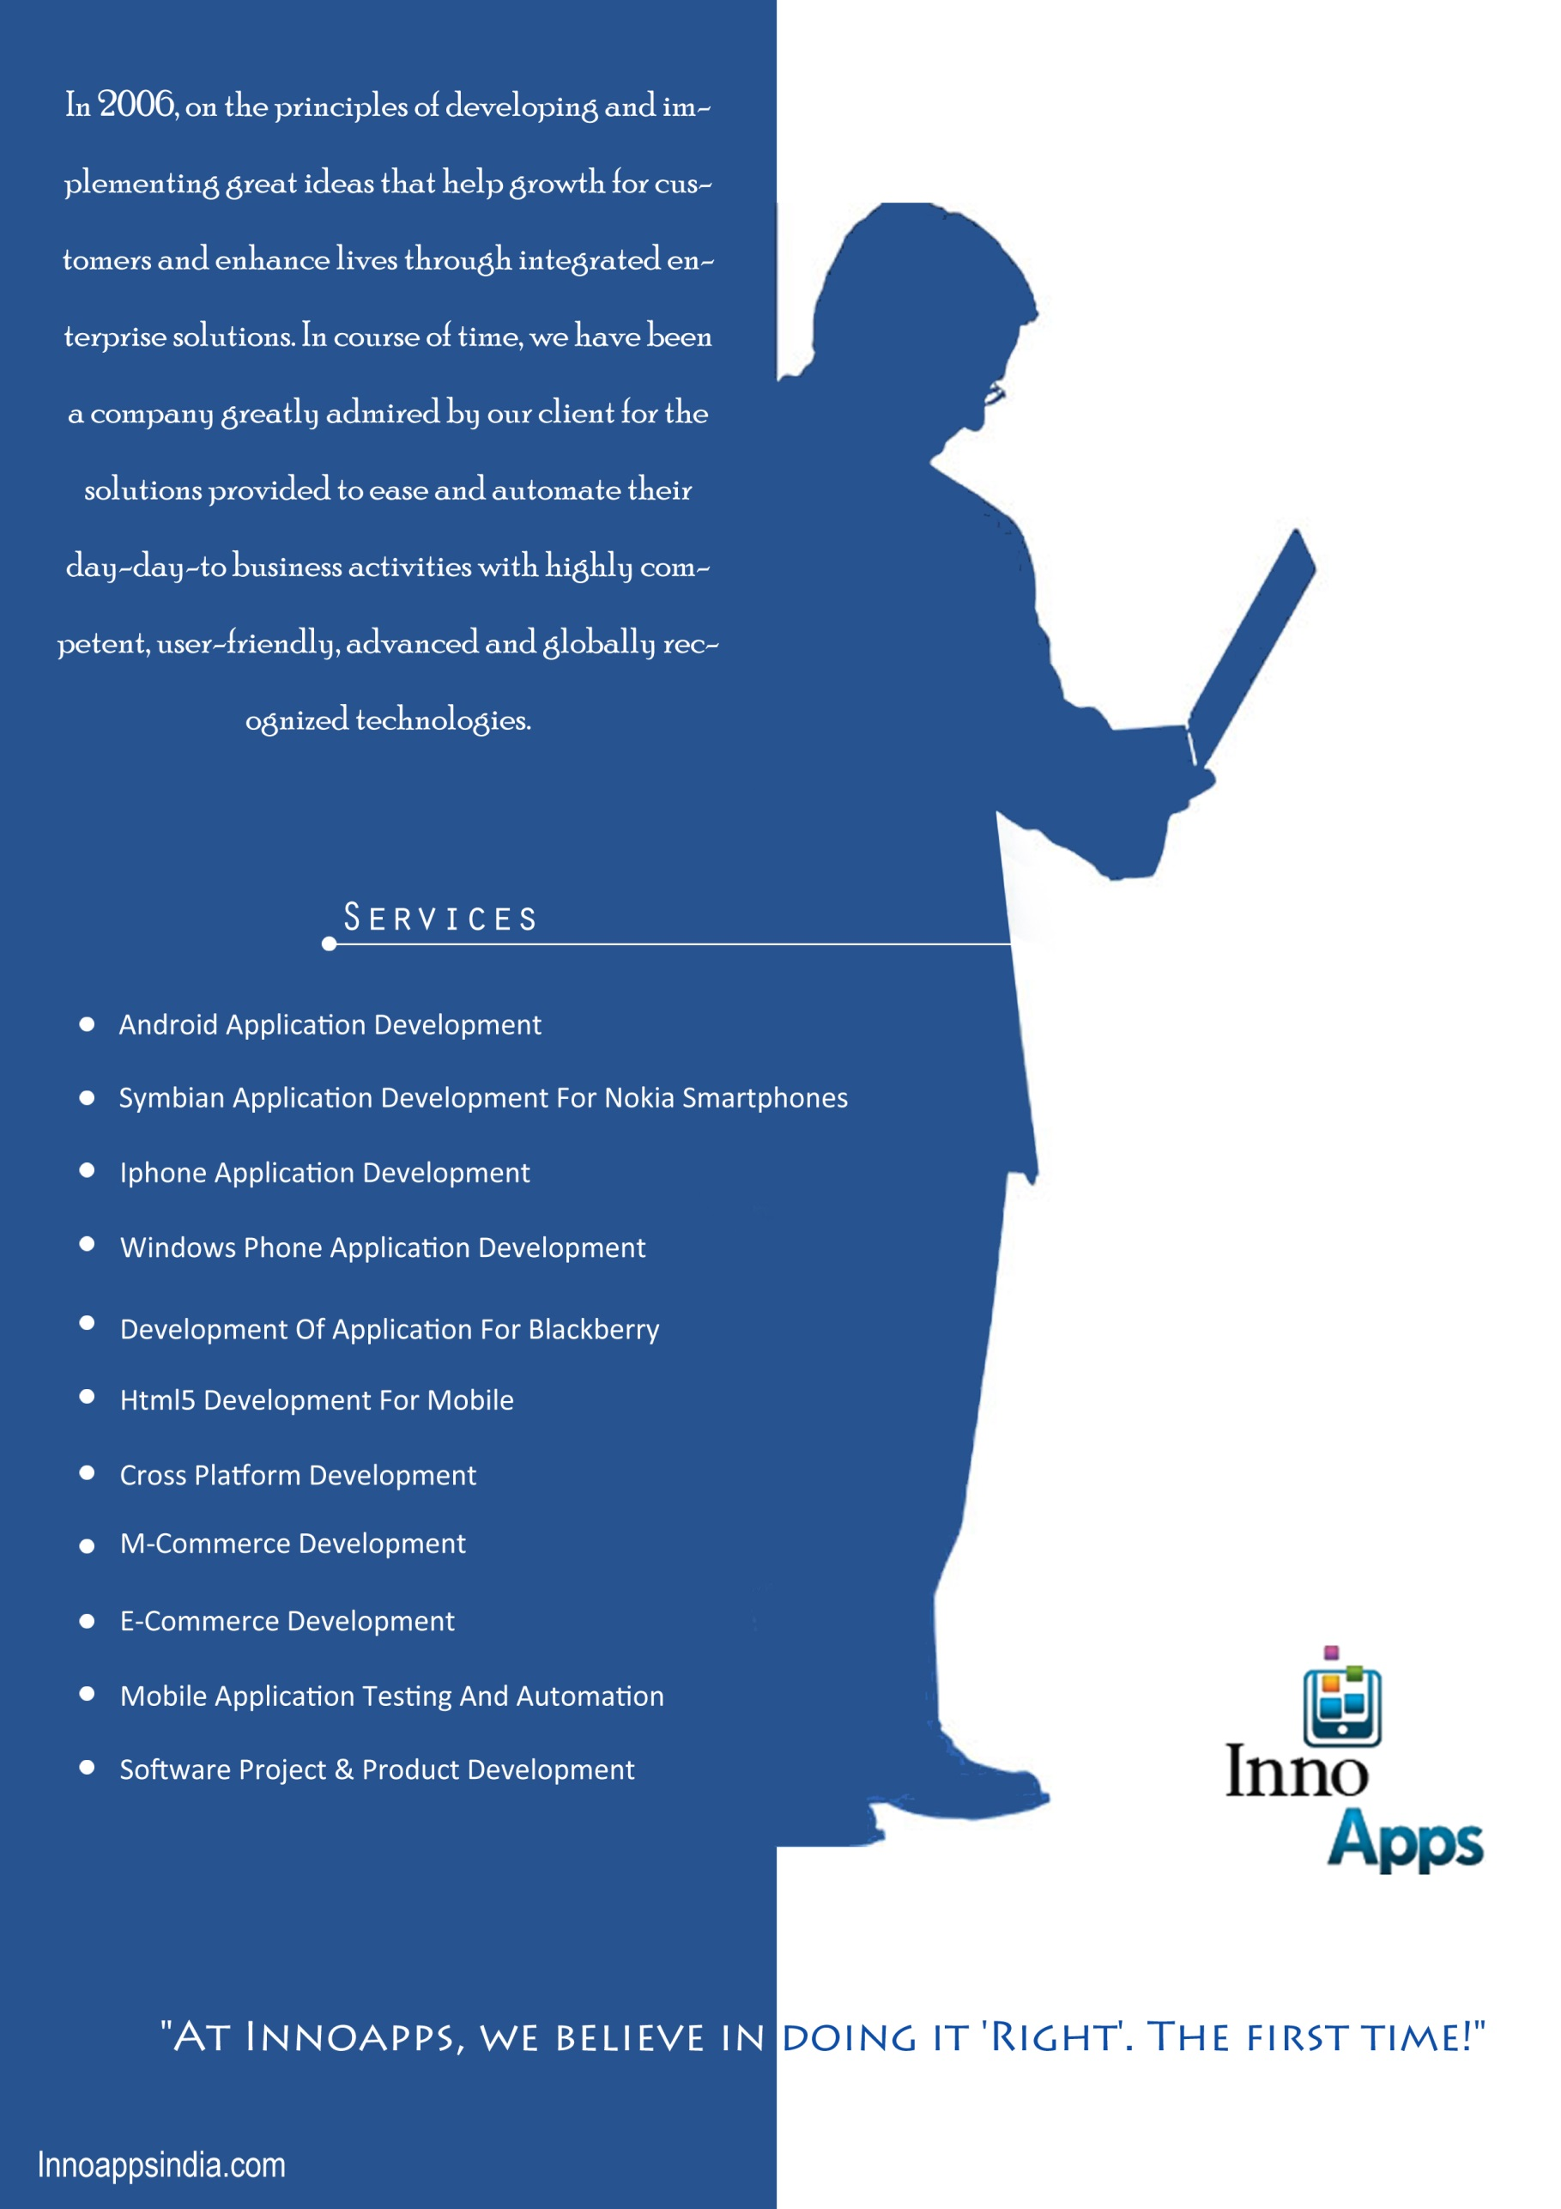

PAPERLESS | FAST | EFFICIENT
CloudLTMS (Leave & Travel
Management
System) on BIO METRIC
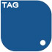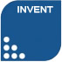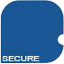

INNO APPS IOT Cloud
- Strategy, and introduction of INNO APPS IOT
- Overview and vertical introduction
- INNO APPS IoT – “The Real IOT solution for Market”
- INNO APPS IoT – 2017 Strategies
- Strategies
- Global Marketing
- Background : INNO APPS IoT a strategic pillar for INNO APPS

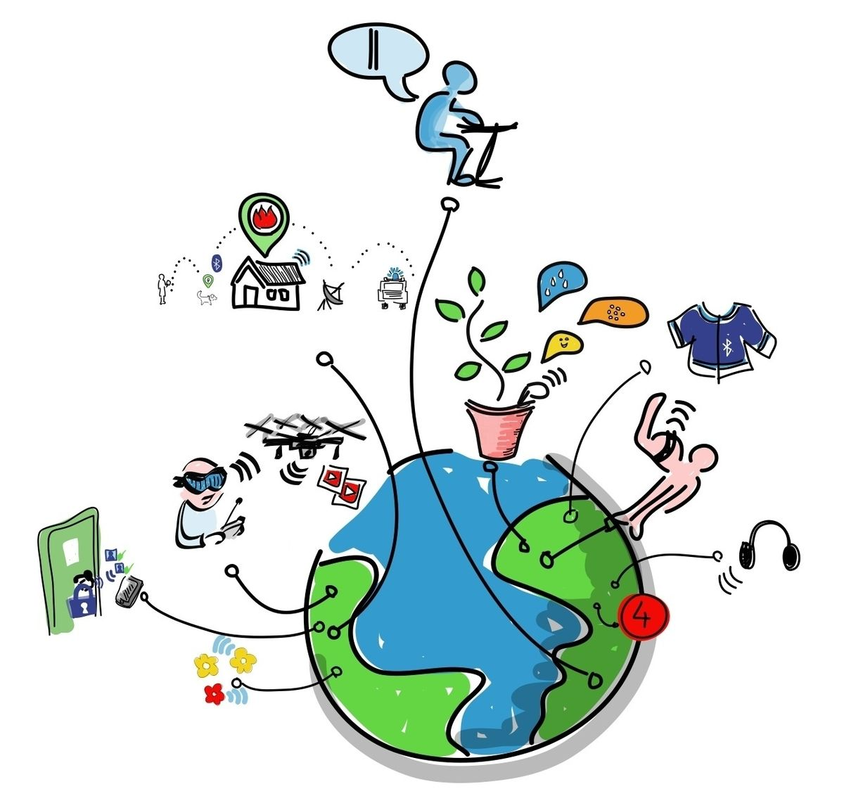

The Internet of Things – Pillar of INNO APPS

Digitization – Connect world on IOT platform

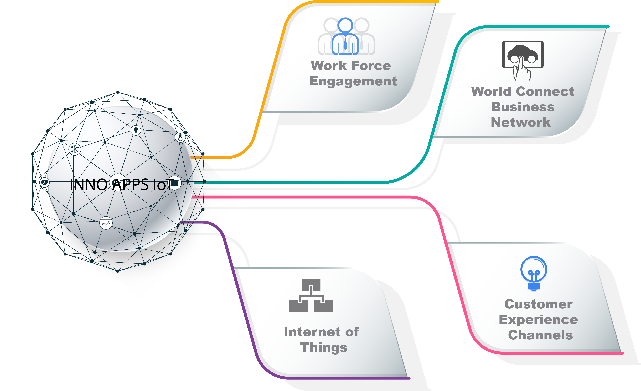
… IoT is the pillar for a digital world

INNO APPS IoT Strategy
INNO APPS provides a highly innovative IoT solution portfolio, which extends the digital core with adaptive applications, big data management and connectivity to enable;
- New Business Processes
- New Business Models

INNO APPS IoT connects with people and processes….
Connecting Things with people and processes

IOT Digital Supply Chain
- Digital Business Planning
- Digital Response & supply
- Digital Logistics
- Digital Product Innovation
- Digital Manufacturing
- Digital Operations

Overview of cloudLTMS ?

The Cloud Leave Management System (CloudLTMS) is an easy-to-use and efficient full Enterprise Mobility Application. The new cloudLTMS streamlines communication between the HR and every individual staff and facilitates a simple-to-use yet efficient system to manage all employee leave matters. At the same time, the cloudLTMS ensures that all leave application and request are accurately accounted so that staffs can apply, approve and view leave records without the hassle and delay through admin staffs – it’s all at a few mouse click anytime, anywhere with broadband Internet access.
The new cloudLTMS has the many features that benefit the staffs:
- Fast & Efficient, the improved leave system has further streamlined the leave application/approval workflows such that it is much more convenient for staff make leave application and managers to approve.
- Easy-to-Use, the new LMS is specifically designed to be intuitive so that the system is very easy to learn and use by the administrators, approving offices and applicants.
- Real-Time Information, the new LMS operates on Real-Time whereby information is updated instantly whenever a leave transaction is completed. As such, all staff can check instantly who’s on leave, applying for leave or other status, etc.
- Supports All Leave Types, the new LMS is designed to support all existing leave types in the organization. All history leave records are tabulated automatically and archived securely in the system.
- Integrates with HR, Time and Payroll System, the new LMS is seamlessly integrated to the BMS to become 1 single system.
- Single Sign-On, there is no need to log into the new LMS again once user has already logon onto the Intranet (Depending on company Intranet Policy).

Scope of CloudLTMS
In a fully integrated cloud environment, Leave management software allows employees to easily manage the full lifecycle of leave management process from balance accrual to applying for leave supported by a robust workflow. It also ensures uniform implementation of leave policy throughout the organization, reducing manual HR monitoring or intervention.
Key features are:
- Applying for Leave: Employees have the ability to apply for leave online via self-service, which is supported by workflow.
- Tracking Approval: Once an employee applies for leave, the request for approval is triggered and the line manager gets a notification for approval. The employees can track the status of approval at any time.
- Cancel Leave: Change is a constant and it is no different with leave plans. Employees can cancel their request for leave via self-service anytime.
- Viewing the available balances: Organizations offer different types of leave policies, which have different rules for accruing the time off that can be availed. The ability to view the balances online by the employee reduces the administrative burden of the HR of the organization.
- En cash Leave: Adrenalin's Leave Management System supports the ability for encashment of leave depending on the business policies.

Modern HR Software

Simple and intuitive CloudLTMS made for humans

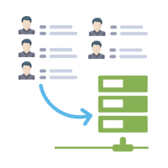  Centralized Information  All your employee information stored in one central location and accessible from anywhere | 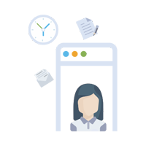  Employee Portal  Invite your employees to login using their email address and easily manage their information | 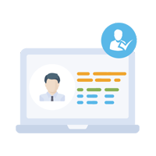Beautiful Profiles  Import all your employees and see all their information presented in beautiful employee profiles
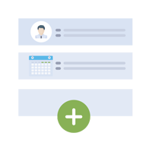  Custom Fields  Don't be limited. Define as many custom fields and set permissions and approvals at each field level | 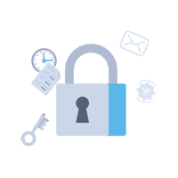  Safe & Secure  All sensitive employee information is secured using bank grade encryption and privacy protection measures | 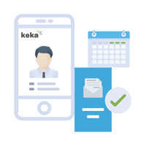  On Mobile  CloudLTMS is built to be mobile centric. People directory, leave, attendance all available on the go!

All employee information in one place
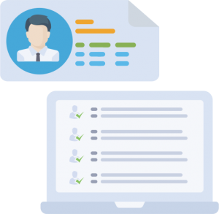

CloudLTMS stores all of your employee information across the locations into a safe and centralized information store that is accesible from anywhere in a secure, controlled manner. All your employee information can easily be collected, imported and stored in the databes.
Turn your messy spreadsheets and files of paper into beautiful online employee profiles. Stay accurate organized, and save time on tedious administrative tasks.

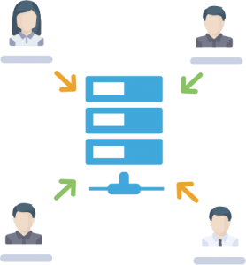
Beautiful Employee Profiles
- No need to remember and grope around hundred different places before finalizing payroll.

- All decisions required to process payroll are consolidated in one screen.
- Pending activities and reconciliation of Payroll right where you need them.

Employee Documents

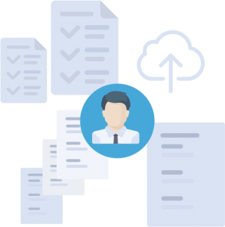
CloudLTMS comes with employee document management system that would allow the HR team or employees themselves to upload and maintain Identity, Education, Work Experience and Internal performance docs in one place. You can define permissions on who has access to these documents.

Leave Module and Features

Most extensive leave management system in the world!

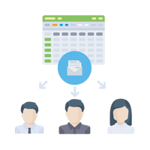  Leave Accruals  Automatic accrual of leaves balances at intervals you choose - weekly/monthly/ quarterly and so on | 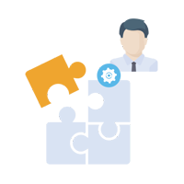  Flexible Policies  Create as many leave policies to suit your employee profiles or working style | 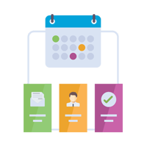  Approval Workflow  Define flexible approval workflows for leave requests. Multi level approval flow
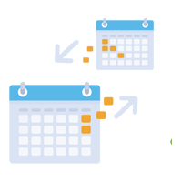  Year End Processing  One click Year-end process! Define your own carry forward and encashment rules on leave balances | 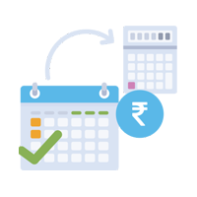  Leave En-cashments  All sensitive employee information is secured using bank grade encryption and privacy protection measures | 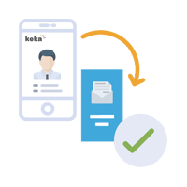  Leaves from Mobile App  Employees can apply leaves from LTMS mobile app. Managers can view and approve from mobile too

Highly Configurable & Flexible

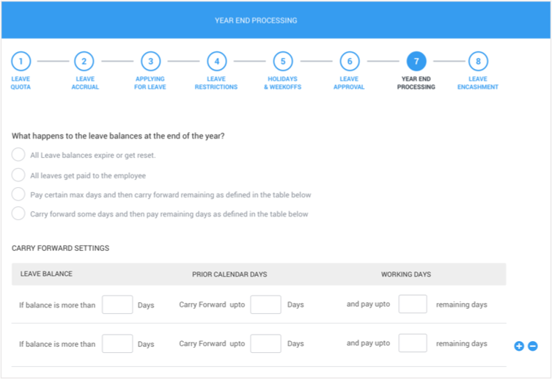
CloudLTMS has most configurable and flexible leave management system. You can design leave policies to suite the nature of your work culture and business goals. Configure as many leave types as you prefer such as Privileged, casual, sick, unpaid leave each with its own policy or simply offer a single unlimited paid leave.

Applying for a leave
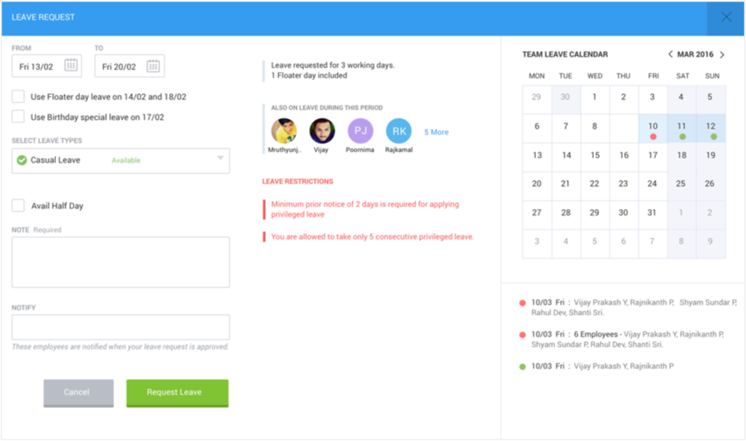
On CloudLTMS platform an employee is made better aware of the context of his actions and actively engaged in decision making thereby increasing his sense of ownership for the company. A simple example is how we involve an employee in leave approval process. When an employee is applying for a leave he is automatically shown who else have already applied/approved leaves on that specific days, so he can judiciously make a decision if his absence can further hurt the project delivery.

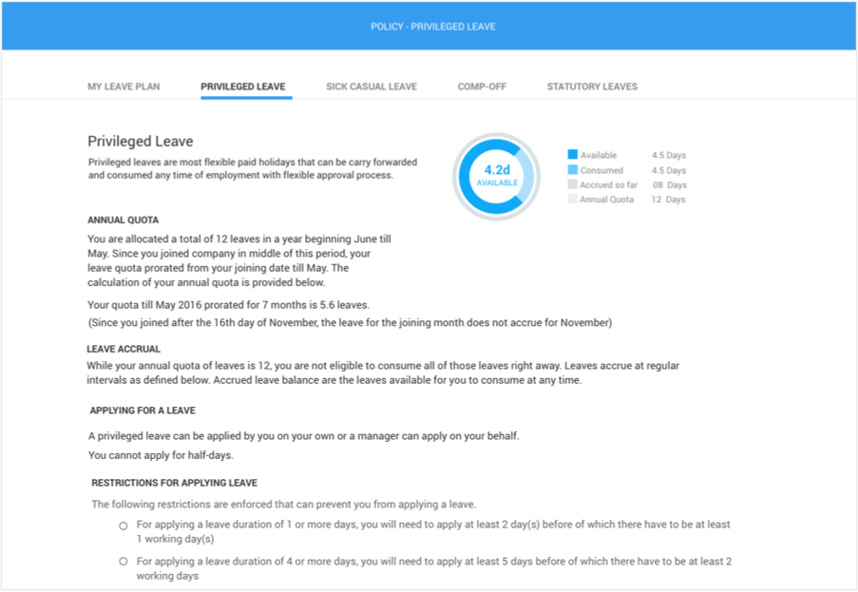
Auto-magical Leave Policy document
Companies design a very robust leave policy only to find that most employees have never read it, as it gets lost and forgotten in black hole of time. At the nick of the time, employee applies for a leave only to find that he cannot apply for a privileged leave due to the restrictions that he never knew existed. This builds up dissatisfaction
CloudLTMS takes care of this problem very well with its automatic leave policy generation engine. It actually creates a Leave policy document per individual based on the leave plan they were assigned and it is made available right where they need it most i.e. When they are applying for a leave. It explains in plain english the 'what and how' of every leave restriction you may have added in your leave configuration.

Leaves during Notice Period
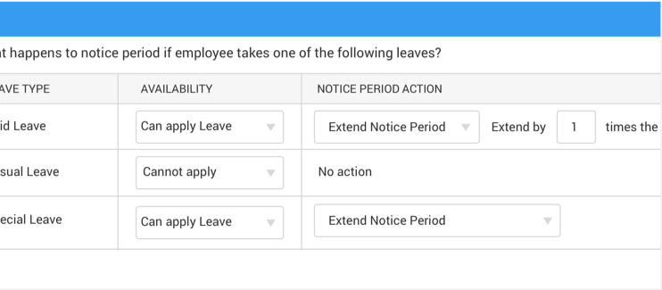
On CloudLTMS platform an employee is made better aware of the context of his actions and actively engaged in decision making thereby increasing his sense of ownership for the company. A simple example is how we involve an employee in leave approval process. When an employee is applying for a leave he is automatically shown who else have already applied/approved leaves on that specific days, so he can judiciously make a decision if his absence can further hurt the project delivery.

Leave Approval workflow
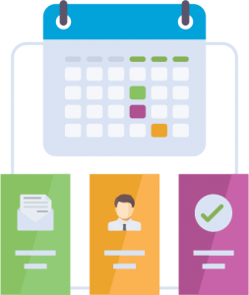
Managers receive leave requests and can approve them right within email or by mobile. If they need more details, they can also quickly check to see the leave usage and balances of the employee and who else in their team have taken leaves. Employees receive an email, confirming the decision either way.
You can configure multi level approval workflows and have the entire thread

Floater Holidays & Special occasions
India is culture of diversity and your company is no different. We have different festivals for different cultures and your employees seek holidays of their choice. Keka Leave Management system allows you to specify as many floater holidays (optional holidays) as you choose and still limit to a number per employee.
And you can show, you care for your employee, by giving them a holiday on their special occasion days - Birthday, Marriage anniversary etc.

Not all employees are same

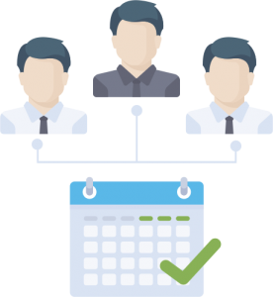
Not all employees or departments are same when it comes their nature of work. This applies to leaves as well. Cloud LTMS allows you to define various leave plans that suit different needs of each of your department or band of employees. Each leave plan can have its own leave types, accruals, balances, carry forward rules and many more. You can choose to have different leave plans based on seniority or probation or even notice period.

Attendance Management

Most robust attendance tracking system in the world with biometric, mobile/GPS and scheduling!
Realtime Tracking  CloudLTMS is the only cloud attendance software that provides realtime tracking from 200+ devices | Shifts & Week-offs  Create various shifts and weekly offs for different groups of employees along with holiday calendars | Employee Perspective  CloudLTMS gives employee their own beautiful perspective view of attendance which encourages punctuality
All-in-one  CloudLTMS is the only All-in-one extensive system in the world with biometric, GPS and Scheduling all included | Overtime Calculation  Track overtime hours from devices and compensate for the overtime from fully integrated Payroll system | Attendance Rules  Enforce punctuality with auto attendance rules for late coming, short hours or missing attendance

Attendance automation at its best

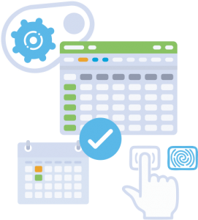
We want HR to do great things. And tracking attendance manually isn’t one of them. And this is where CloudLTMS comes to rescue. LTMS Attendance Management system does end-end automation of tracking, managing and scheduling employee hours and it does in a seamless manner with your existing biometrice infrastructure.

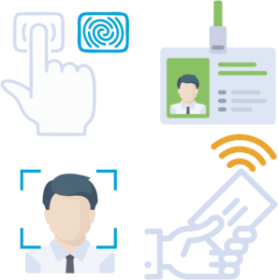
Realtime integration with 200+ Devices

CloudLTMS is the only cloud platform in the world that does realtime integration with all attendance devices types - Biometric, Smart Card, RFID, Facial recognition devices, Near Field Communication NFC devices. Our universal driver framework supports 100+ hardware devices from vendors across the world. When your device is connected to your LAN, all you have to do is install integrate our LTMS software, all time devices on your network and synchronizes the attendance data with CloudLTMS server.

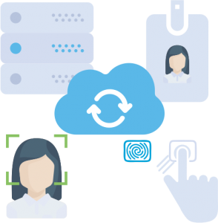
Seamless Sync that actually works

When you integrate your existing hardware with CloudLTMS, you will realize instant benefits of a seamless integration in action. CloudLTMS takes away all the pain associated with manual uploads or meddling with your attendance software. Runs in the background silently. Recovers and retrieves logs even after many days of network downtime. CloudLTMS proactively warns you when devices fail to record swipes or are recording incomplete swipes, which is quite a common scenario.

Alerts and handles device-failures

CloudLTMS is the only cloud attendance system that gracefully handles Biometric device failures and proactively alerts the IT Admins. It is quite common for attendance device to abruptly disconnect from network for various reasons. CloudLTMS gracefully recovers all your past offline logs from the attendance device and restore synchronization. We have customers located in rural areas, hilly terrains and north east Indian states successfully using our software without issues.

GPS & Mobile Attendance

Fully integrated with biometric attendance and shift management
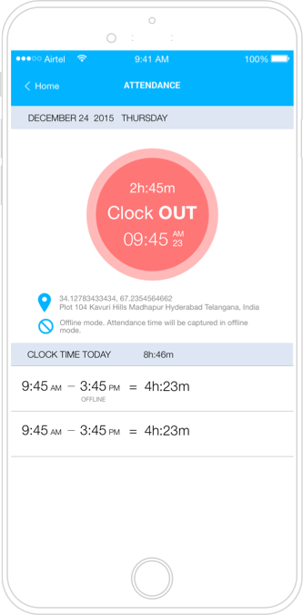

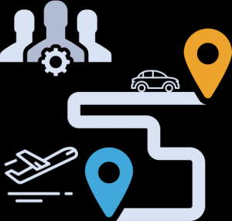
Increased mobile workforce productivity

Businesses often suffer due to inefficiencies and inability to track mobile workforce productivity. GPS tracking for employers, however, puts managers in control by letting them view real-time information about their mobile workforce. When managers have the tracking information they need, productivity can improve dramatically. Whether it is your field sales team or service agents, productivity can dramatically improve.

Pinpoint location & time
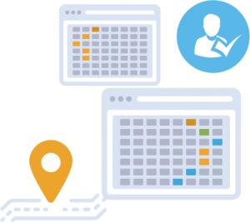

Tracking attendance of mobile workforce itself is a daunting task. With CloudLTMS Attendance tracking, you can now add location detail to the time stamps and the combination is killer. You can exactly know and trace your employee whereabouts leading to effective utilization of their time on the field.

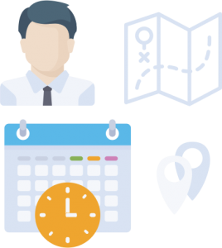
Track employee time - in office or on field

CloudLTMS tracking works well in scenarios where you have employees working in office and or on the field. They can clock-in while in office, go on field to visit a customer and punch their time at the client location. Come back to work and clock out for the day. The time clocking becomes completely seamless when you have your in-office attendance integrated with your biometric access devices!

Works offline in no signal areas too

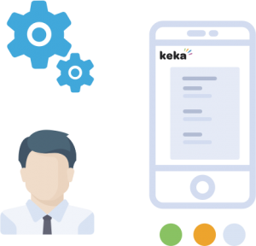
Mobile tracking of time and location becomes useless when your remote staff are in areas with less cellular network coverage. With CloudLTMS tracking, you don’t have to worry about no signal tracking. We got the offline covered too. The app tracks the time and coordinates to the best of the information available and syncs back with our servers, when the device is online again.

Works on Android & IPhones
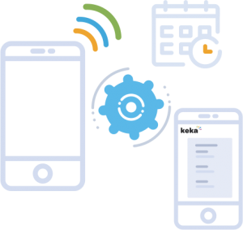

Mobile GPS tracking works seamlessly whether your employees use Android or IOS devices. With the smartphones becoming ubiquitous and handy necessity for everyone, you can be sure the mobile attendance tracking software works with all of your employees.

LTMS Time Sheet

Track billable and non billable hours on projects - internal or external
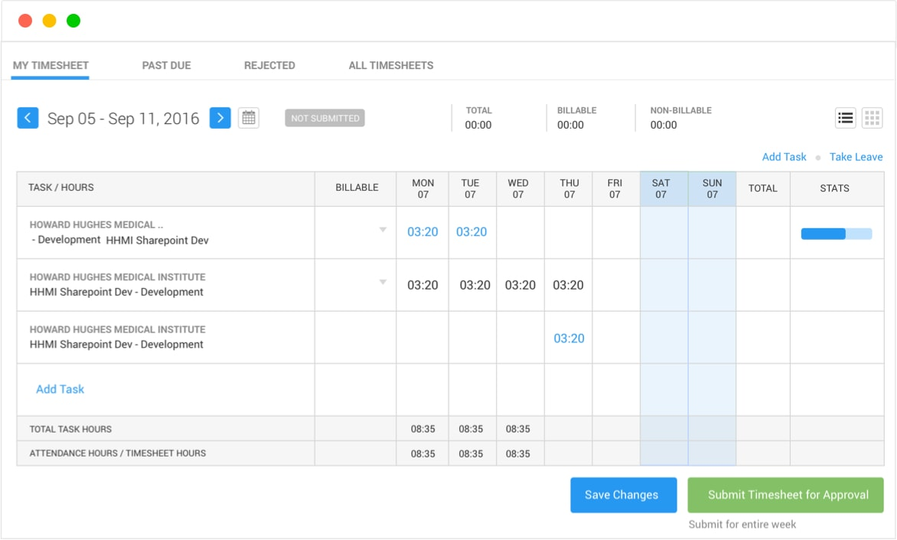

Time tracking made simple
CloudLTMS timesheet is the most convenient and easy to use Time tracking software to track your employee time on your internal and external projects. Entering time entries just takes three steps - Select your project (organized by client), select the task, and enter your time. Once your time is entered, you can enter comments, use timesheet reporting to get budget feedback or dig deeper into projects.

Custom Report Generation
Instant reports can be generated for Timesheets based on the Clients, Tasks and Departments into CSV and PDF formats for cross platform communication. Keka timesheet software allows employees to view respective timesheets based on calendar to keep a track of multiple details on the same screen.

Modules Available in CloudLTMS
- Employee Management System
  - Hr can enroll employee, can add, edit and delete employee details
  - Hr can allocate leaves to employee
  - Hr can allocate expenses to employee
- Attendance Management
  - Hr can manage attendance of employees
  - Employee can monitor their attendance
- Leave Management
  - Leaves and leaves types can be updated by Hr according HR policy of the company
- Holiday Management : Hr can maintain holiday list in a year.
- Payroll management : Hr can run their payroll by using payroll module.
- Announcements
- Manage Awards
- Manage Expenses

Features of CloudLTMS
- Multi Office Shift
- Multiple clock in / out
- Multiple office location
- Manage employee contracts
- Multi level leave approval
- Multi level expenses approval
- Employee self service
- Advanced payroll
- Task user rating
- Attend from mobile
- Graphical representations
- Easy accessible reports

Advantages of CloudLTMS
- Eliminates the use of paper leave application forms
- Is cost efficient
- Provides GUI and Digitalization
- Easy to maintain in Centralized Database
- Leave applications can be submitted via network
- Leave application can be approved easily and notified to respective staff
- Both the leave applicant as well as the approver can view the balance leave and past leave applications
- Calculate the number of leaves taken on monthly / yearly basis
Hierarchal Flow of Leave Management

Applicant consults RO and CO of intended leave dates

Applicant access CloudLTMS system to file a leave application. Leave balance/eligibility are computed by the system

Applicant specifies intended leave dates. Select Approver, RO and CO. Submits application.

CloudLTMS system will generate emails to Approver, RO and CO.

Approver approves or rejects leave application.

CloudLMS system will generate emails to inform applicant, RO and CO.

Leave records are electronically update in the CloudLMS system.

Applicant submit supporting documents to
HR directly (where applicable)

Cloud LTMS product walkthrough
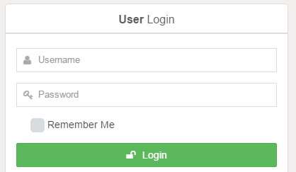
Fig: Cloud LTMS Admin & User Login Screen
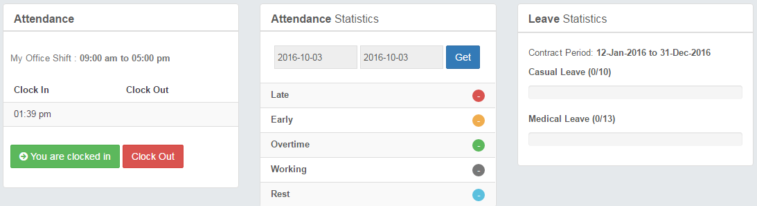
Fig: Cloud LTMS Admin & User Dashboard Screen

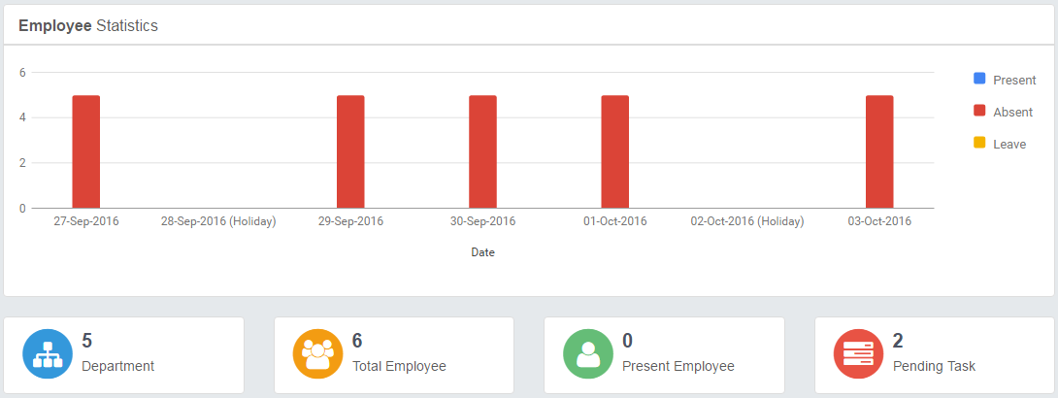
Fig: Cloud LTMS Admin & User Statistics

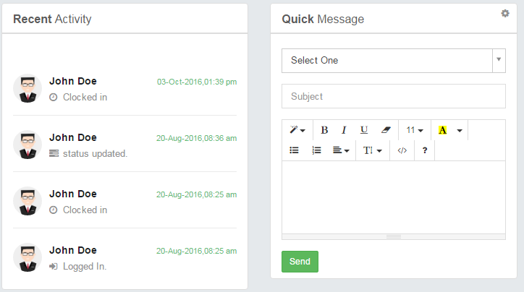
Fig: Cloud LTMS Activity Screen

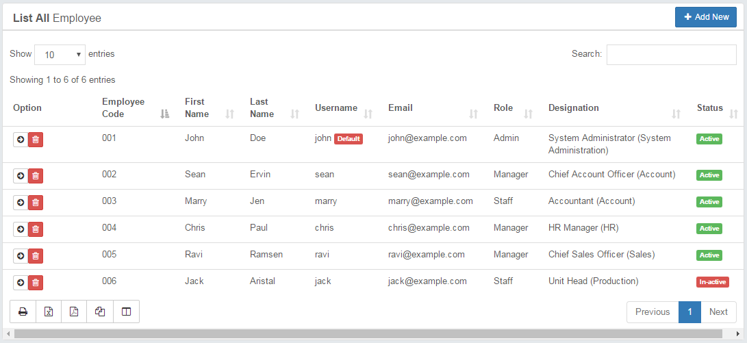
Fig : Employee consolidated report

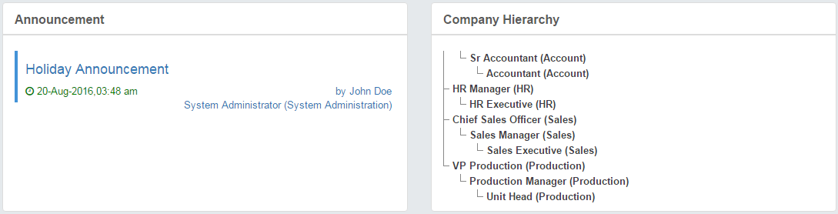
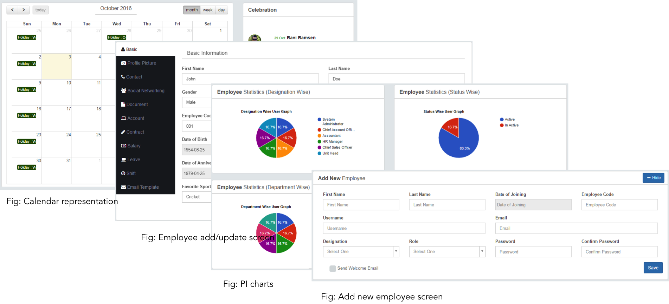

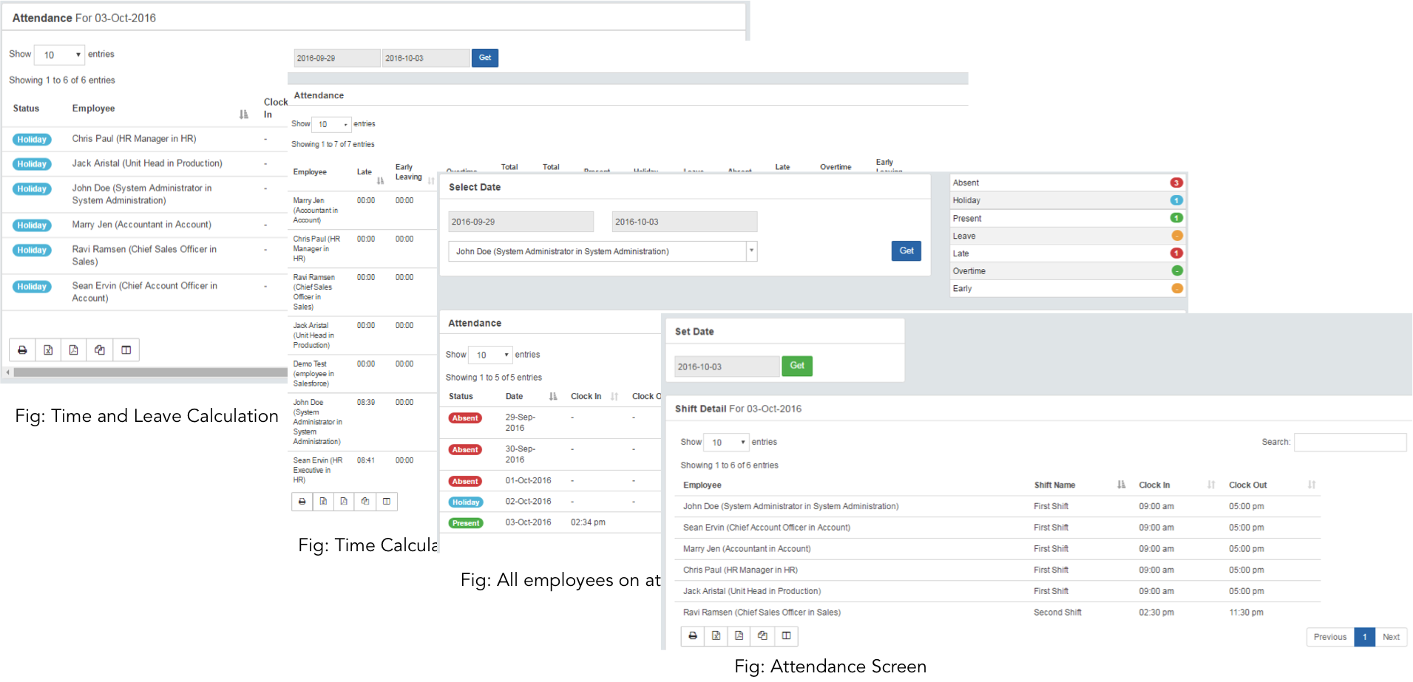
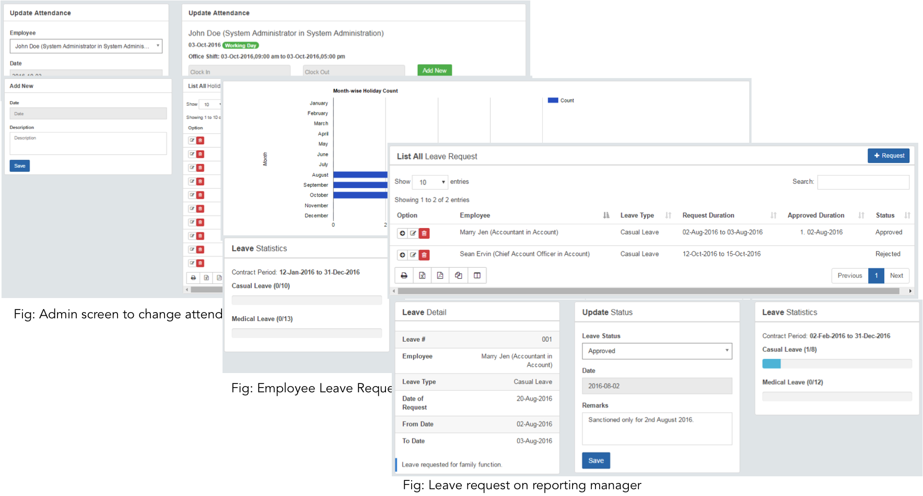

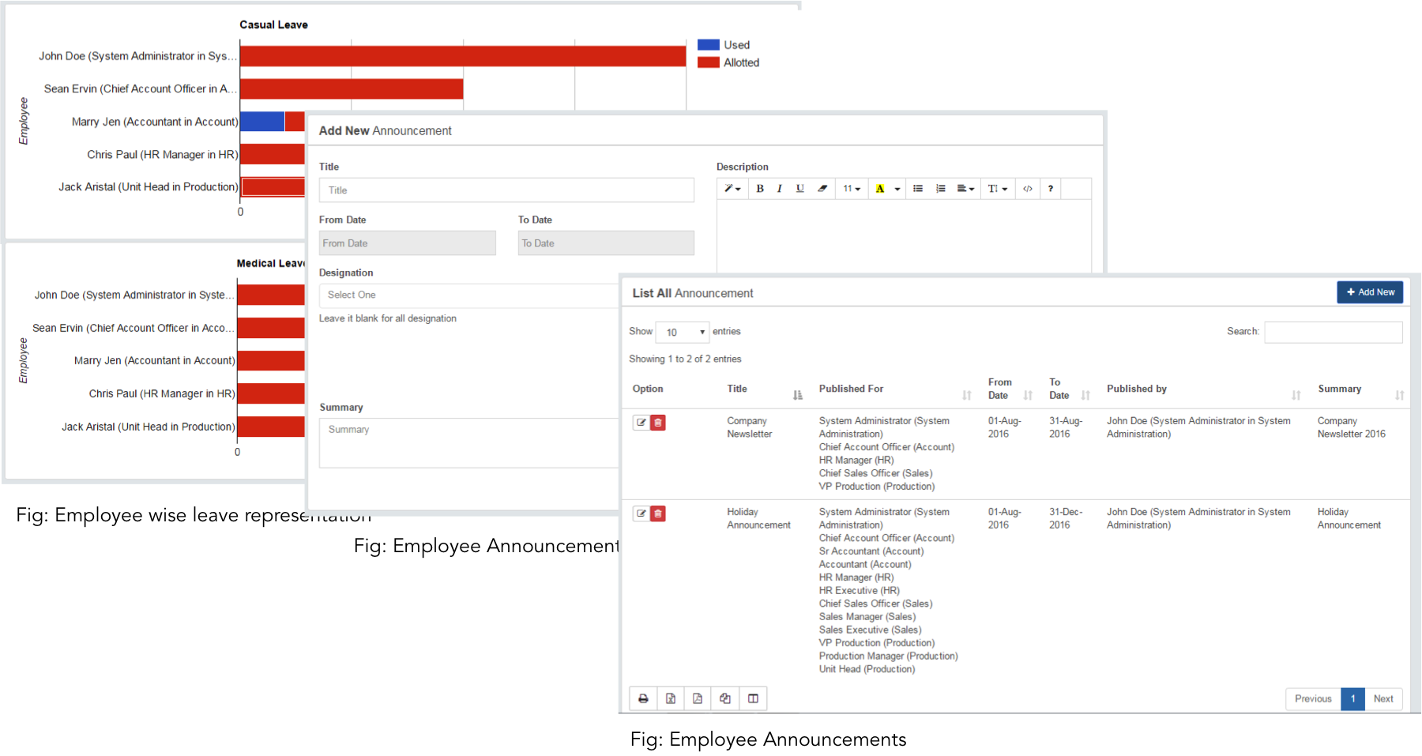

Approve Cycle
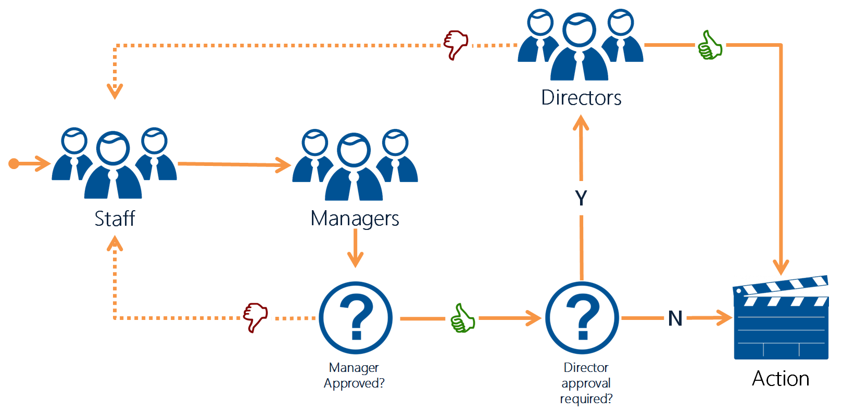

Cloud TMS Walkthrough
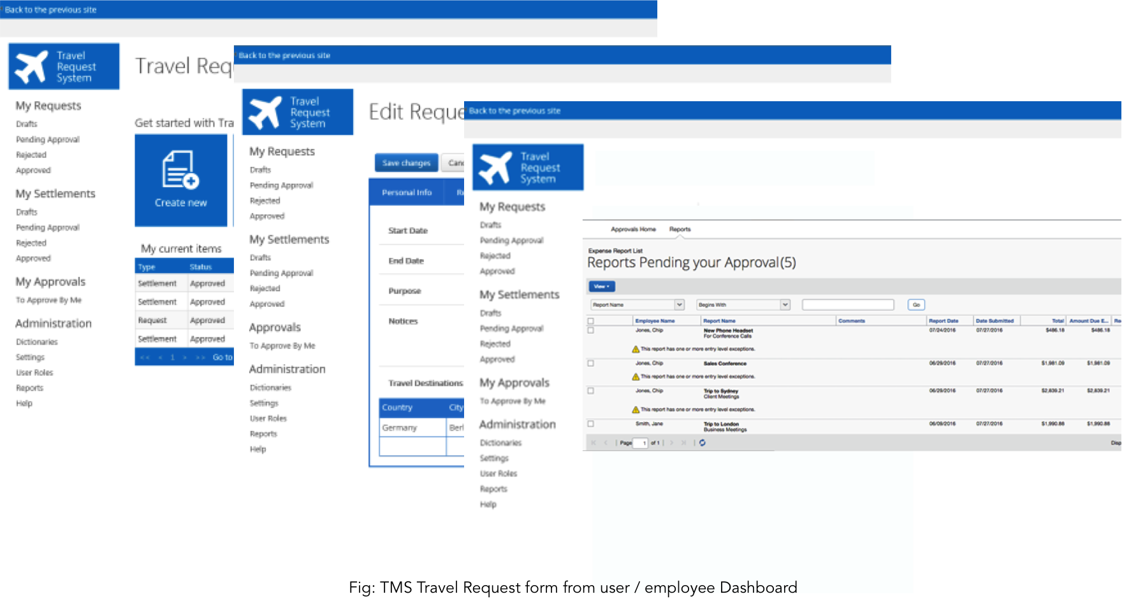

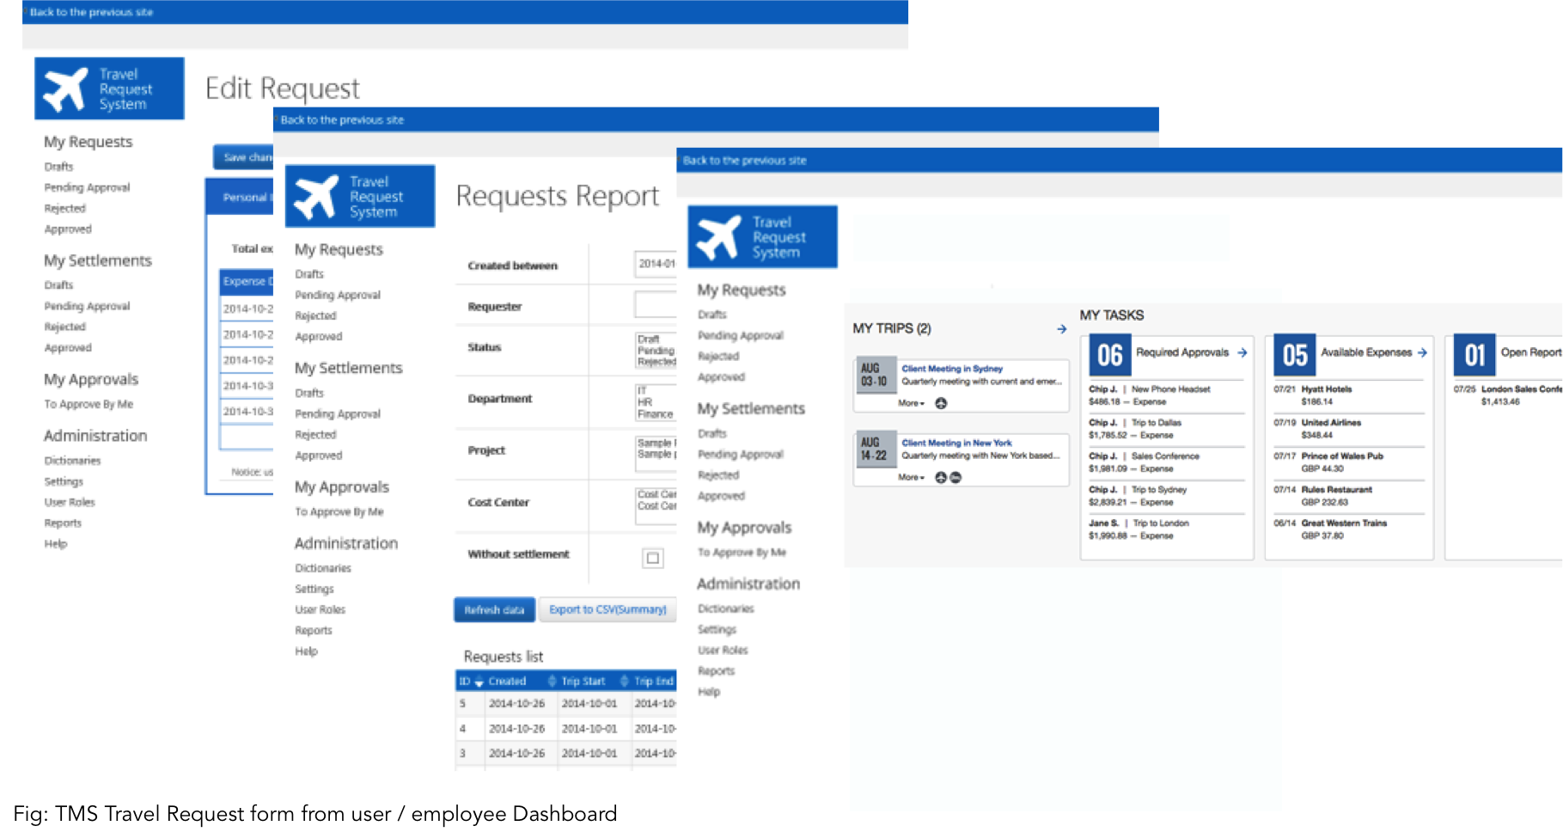

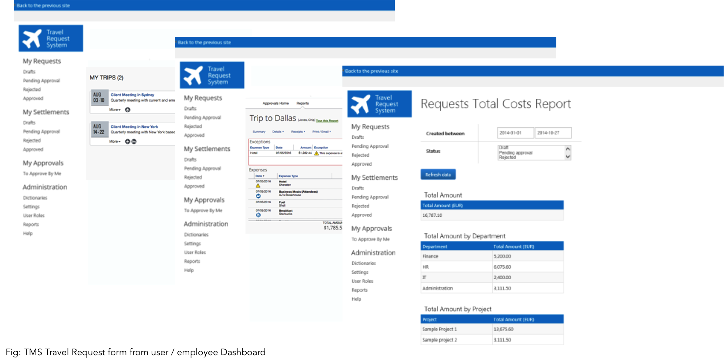

Integration with Bio Metric Devices

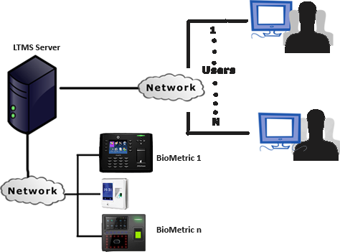

Biometric devices are capable components, which can serve different individuals and organizations, ardently looking for first-rate security. Helpful in monitoring the activities of various people entering and leaving the organization, these devices are becoming mandatory security systems.

Integration with ERP’s

The overall solution is built on a diverse architecture including an on-premise framework (i.e. Laravel) with the cloud-based mobile platform and an on-premise Frame based BPM Suite instance. The solution is scalable and can be used with other ERP systems as well.

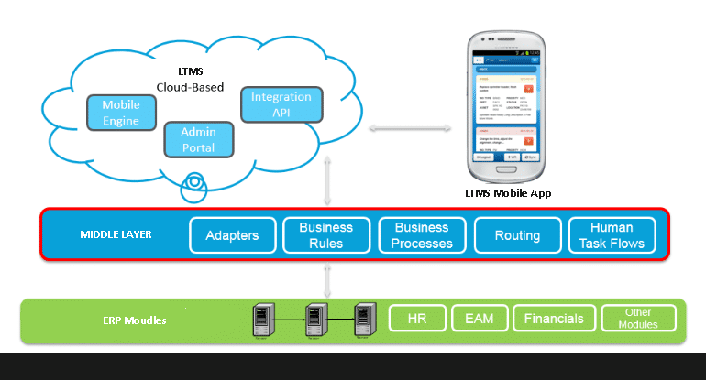

iEMPTS - Employee Indoor Tracking System

i-EMPTS is a comprehensive, Employee / Staff / Field Executive monitoring, control and management system. It’s an effective low cost operation for fleet and HR operators, corporate organizations and agencies, Government. The essence of telemetry and use of location based services (LBS) is to enhance security, efficiency and reduce operation cost. It is a GPS / BLE (RTLS) / RFID Employee Tracking Solution which works with Web Application, Android, iPhone App. Employee tracking systems, also known as personnel tracking software, utilizes bar code, magnetic stripe, proximity, smart credential or RF-enabled ID badges.
i-EMPTS, whether it be in an office setting or at a construction site, can be scaled to fit applications of all sizes, from a simple stand-alone employee time tracking software to a complete solution that is integrated with an access control system. If an out-of-the-box solution is not available for your application or doesn't quite fit your requirements, INNO APPS can custom develop an employee tracking solution based on your needs.
Types of Tracks available in the product is;
    - Indoor Tracking System
    - Out door Tracking System
        - Plant tracking
        - Sales / Marketing person tracking
Track all your field sales force LIVE Location across globe from smart phone through GPS tracking.
i-EMPTS Provides Best Field Force Tracking
For Sales / Marketing People: Our Sales Employee GPS tracking system allows you to manage your business resources effectively, providing access to vital information that helps to improve your sales / services and reduces cost. It is the solution which can show you all the required details of your business Employees with alert and reporting features.
Employee / Person Tracking: Solution also enhances effective monitoring and control of personnel. We are an advanced Monitoring System with management capabilities that offers much more features than a standard GPS Tracking system at comparable, or in most cases lower cost. The system is backed by sophisticated developers and engineers with the ability to customize expand and successfully deploy it to virtually any application.
Workforce GPS / BLE / RFID Tracking Features:
  - Live Employee Location – Know EXACT location of your staff in Google Maps during office hours
  - Time Specific Tracking – Track ONLY during specific pre defined timings
  - One touch Group Notifications – Send messages to ALL your employees / departments at once
  - Department / Branches – Option of adding as many departments and employees for tracking
  - Auto Capture Attendance – Marks attendance based on defined time & location
  - Location Proof – Upload Geo-tagged images as proof of Location.
  - No Internet, Not to worry, No data loss! – App works offline, once you get connected to internet everything is synced to server
  - Many More – API Integration, Notes, Distance Travelled (KMs), SOS
  - Field Staff Mobile Tracking Application / Sales force GPS Employee / People tracking in India
  - Cloud based GPS Vehicle & Field Employee Tracking System platform used in over many countries for real-time tracking of People, Cars, Fleet & Assets using
For Sales Employee Tracking App provide Free Android Mobile Phone Application and iPhone Application with i-EMPTS software (web based ) !! Our GPS based field employees Tracker have a unique feature which can work completely offline with Automatic Attendance option with Live monitoring and workforce automation on Web, Android and iPhone apps.
You Can track your Employee/Field Staff Live Location through Android and iPhone App, Industry where i-EMPTS is effectively used are Sales, Service, Pharma, Advertising & Campaigns, Logistics & Ecommerce, Security & Patrolling, High Value Goods, FMCG Industries, Family Tracking, (Personal Tracking ) Vehicle & Driver Tracking.
- i-EMPTS lets you track and locate your staff indoor and outdoor.
- i-EMPTS lets you track and locate your field staff.
- i-EMPTS supports geo-tagged attendance of your sales team.
- i-EMPTS gives you accurate distance travelled.
- i-EMPTS supports client check-in and check out and geo-tagged evidence upload
- i-EMPTS tracks metrics that matter to you so measure efficiency
Feature of iEMPTS
- Digital Forms
- Location Tracking
- Geo Tagged Proofs
- Real Time Updates
- Task Management
- Order Management
- Geo Attendance
- Data Security
- Hardware Integration
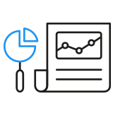  MAKE WORK INTERESTING  See your customer information in Pie Charts, Bar Graphs and more – viewing information not only makes work interesting but also drives better output! | 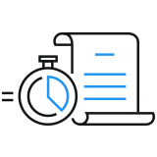  REAL-TIME UPDATES  Imagine having reports for every task completed, every job done and every customer visited instantly available to you. Keep up to date with your field team’s updates, has never been easier! | 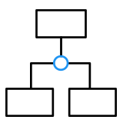  YOUR BUSINESS, YOUR TERRITORIES  Scaling business starts with visualizing your business. What better to visualize than with Areas and Territories of your presence! | 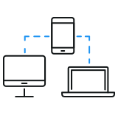  UNIFIED FORMATS, FOR ALL.  With your team using a singular format for filling out customer responses, client feedback and retailer grievances – it becomes a lot easier to boost effectiveness of your team.
Maximize Transparency | 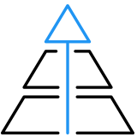  Boot Efficiency | 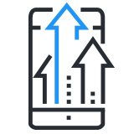  Work at scale | 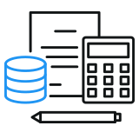  Minimize Costs

